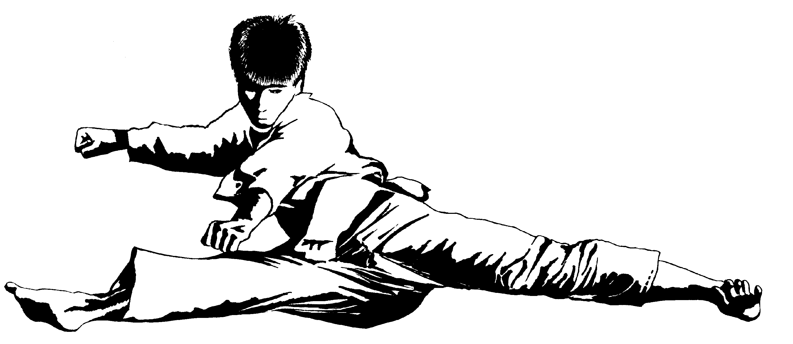
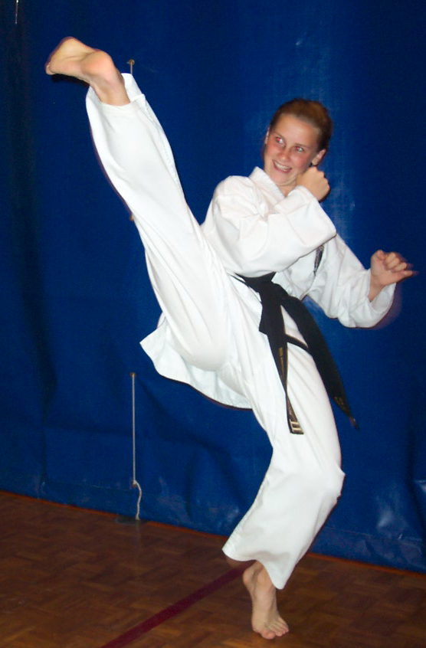
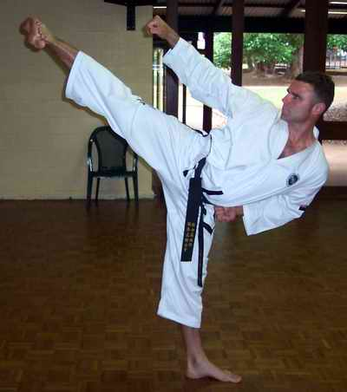
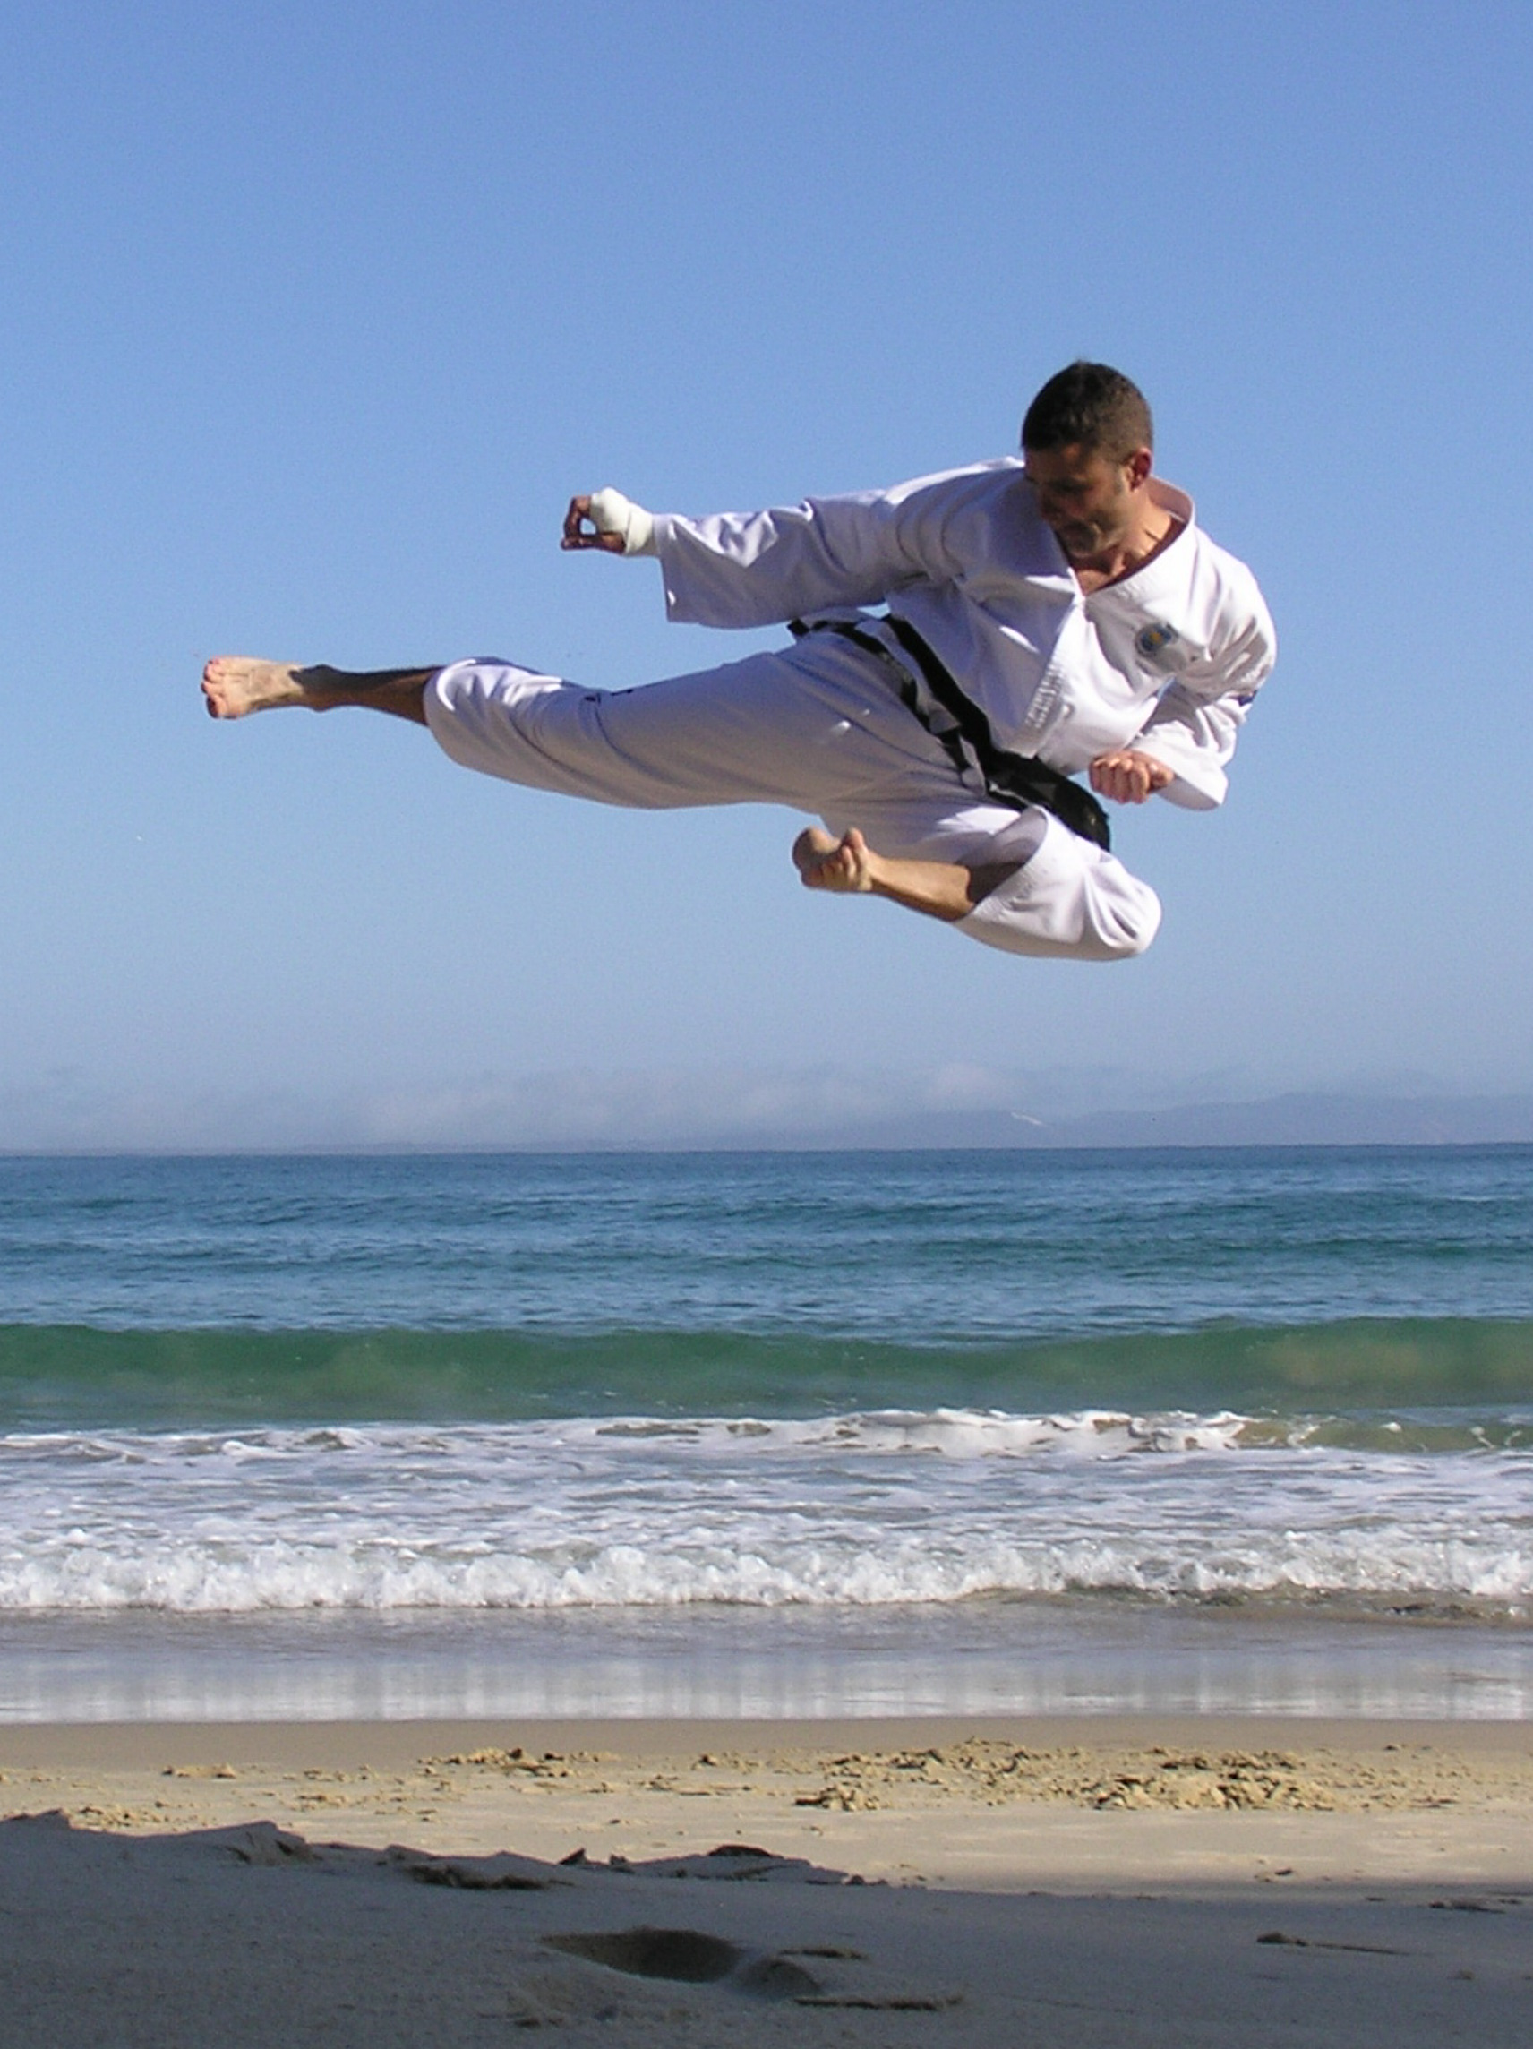
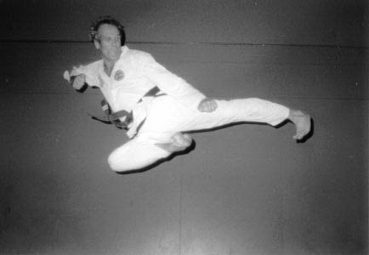
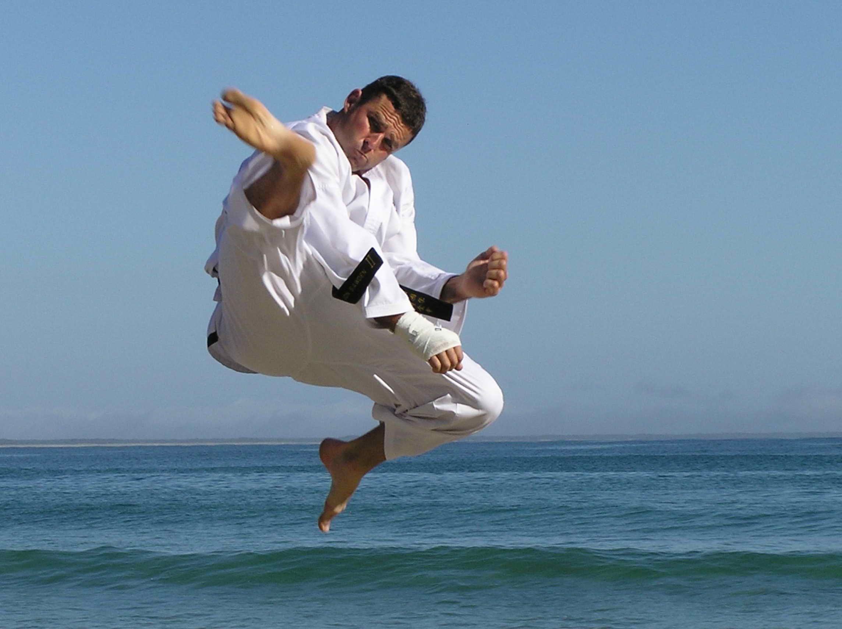
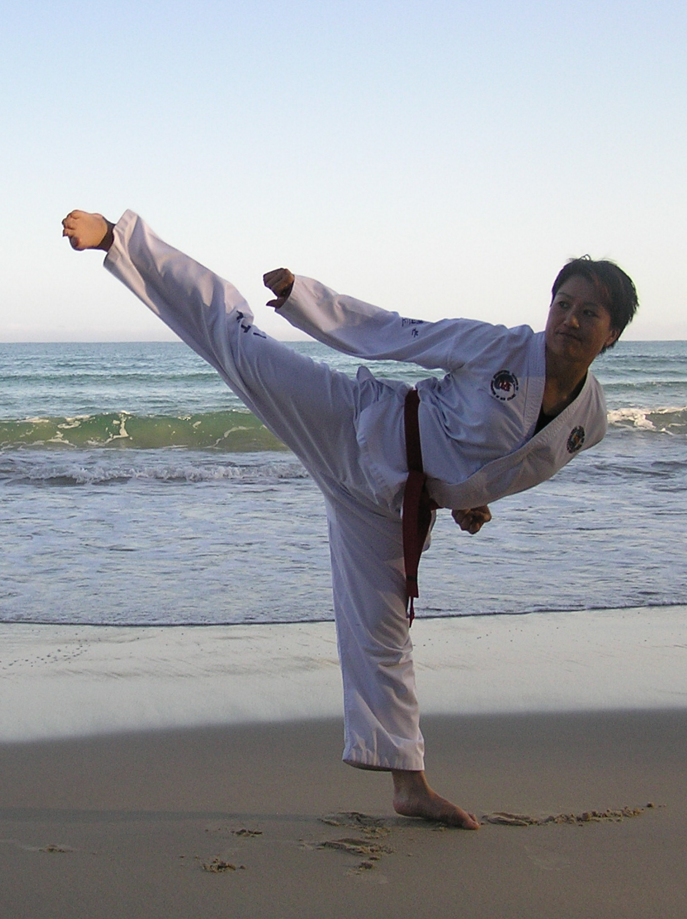

Kicking Seminar
Auckland
Saturday 30th July 4.00pm – 6.00pm
Learn from Coaches to World Champions
Mr Jon Sawden, Master Rocky and Mrs Trish Rounthwaite,
Man Cave 198 Marua Rd, Ellerslie
Green stripe and above
$20 individual, $35 family of two, $45 family of three or more
Pre seminar registration required at http://itkd.co.nz/events/register/event.php
(Pay on the day)
Photos include – Carlie Dann, Mark Rounthwaite, Jon Sawden
Nichola Tse, Master Rocky Rounthwaite

